|  |  |
| --- | --- |
| Date | 25 June 2025 |
| Team ID | LTVIP2025TMID20843 |
| Project Name | Visualizing Housing Market Trends: An Analysis of Sale Prices and Features using Tableau |

## 1. INTRODUCTION

### 1.1 Project Overview

The "Visualizing Housing Market Trends" project focuses on uncovering insights from housing sales data through interactive and meaningful visualizations. Using Tableau Prep for data preprocessing and Tableau Public for dashboard creation, the project transforms raw housing data into actionable insights. Key trends such as the effect of renovations on house prices, house age distribution by features, and overall sales patterns are visualized to help stakeholders understand the dynamics of the real estate market. The project emphasizes clarity, interactivity, and decision support for real estate analysts, managers, and marketing teams.

This project aims to visualize and analyze key trends in the housing market using Tableau. By utilizing data preprocessing techniques in Tableau Prep and designing dashboards in Tableau Public, this project enables real estate stakeholders to gain actionable insights.

### 1.2 Purpose

## The purpose of this project is to assist stakeholders in interpreting complex housing datasets without relying on manual spreadsheet analysis. By cleaning, transforming, and visualizing the data, the project provides an intuitive interface to monitor key performance indicators, renovation impacts, and feature-based comparisons. This enables faster, data-driven decisions, improves pricing strategies, and enhances competitiveness in the housing market. The dashboards created aim to bridge the gap between data and actionable business insights.

## 2. IDEATION PHASE

### 2.1 Problem Statement

**Real estate analysts, marketing teams, and executives at ABC Company** struggle to make confident, data-driven decisions due to the complexity and volume of housing data.

Despite having access to raw housing records, they face challenges in identifying patterns, understanding the effect of renovations on sale prices, and evaluating how house features like age, bathrooms, bedrooms, and floors influence market value.

These stakeholders lack a **centralized, visual platform** that presents key insights at a glance resulting in missed trends, delayed decisions, and inefficient pricing strategies.

### 2.2 Empathy Map Canvas

An empathy map is a simple, easy-to-digest visual that captures knowledge about a user’s behaviours and attitudes.

It is a useful tool to helps teams better understand their users.

Creating an effective solution requires understanding the true problem and the person who is experiencing it. The exercise of creating the map helps participants consider things from the user’s perspective along with his or her goals and challenges.

**Who is the user?**

The users of this project are **real estate analysts** and **executives at ABC Company** who need clear, actionable insights from housing data to guide pricing and renovation strategies. They value interactive Tableau dashboards that simplify complex data, highlight key trends like renovation impact, and support quick, confident decision-making. This project helps them overcome challenges with raw data by delivering visual, filterable summaries that enhance clarity and business impact.

**Key user insights:**

The empathy map reveals several user insights. The user:

Says things like “We need to know what features affect sale price the most” and “Is renovation really increasing value?”

Thinks about “Are we focusing on the right zip codes or property grades?” and “If I miss a trend, we might price homes poorly”.

Does actions like “Uses Tableau dashboards for analysis and presentation” and “Compares sale trends and pricing patterns by features like bedrooms, age”.

**Example for this project of Visualizing Housing Market Trends: An Analysis of Sale Prices and Features using Tableau:**

### 2.3 Brainstorming

**Brainstorm & Idea Prioritization:**

**Step-1: Team Gathering, Collaboration and Select the Problem Statement**

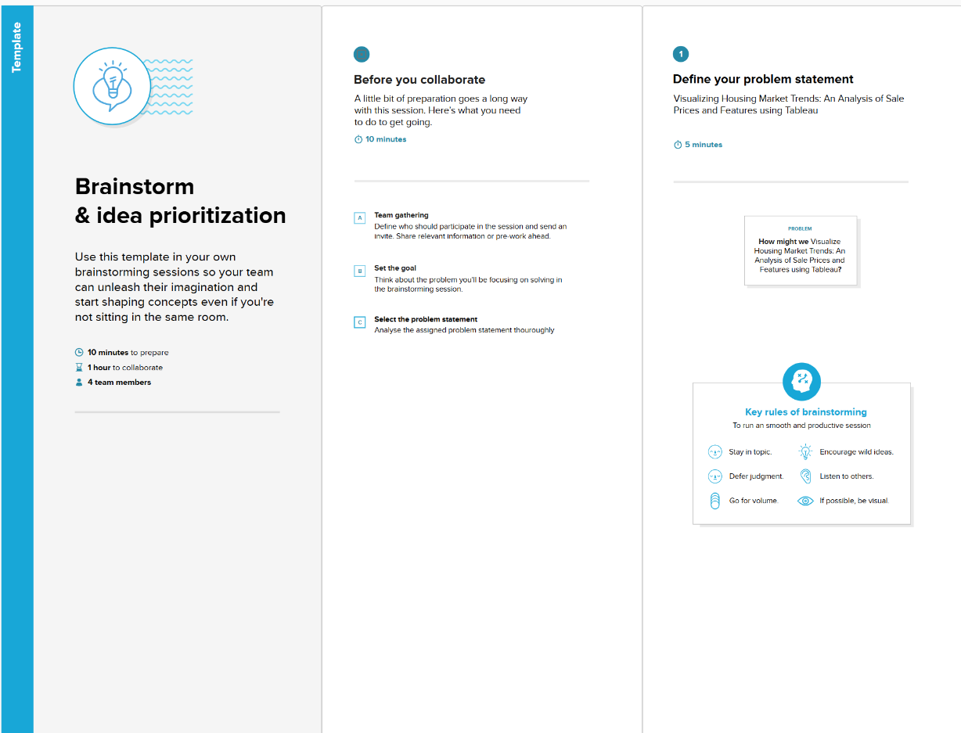

**Step-2: Brainstorm, Idea Listing and Grouping**

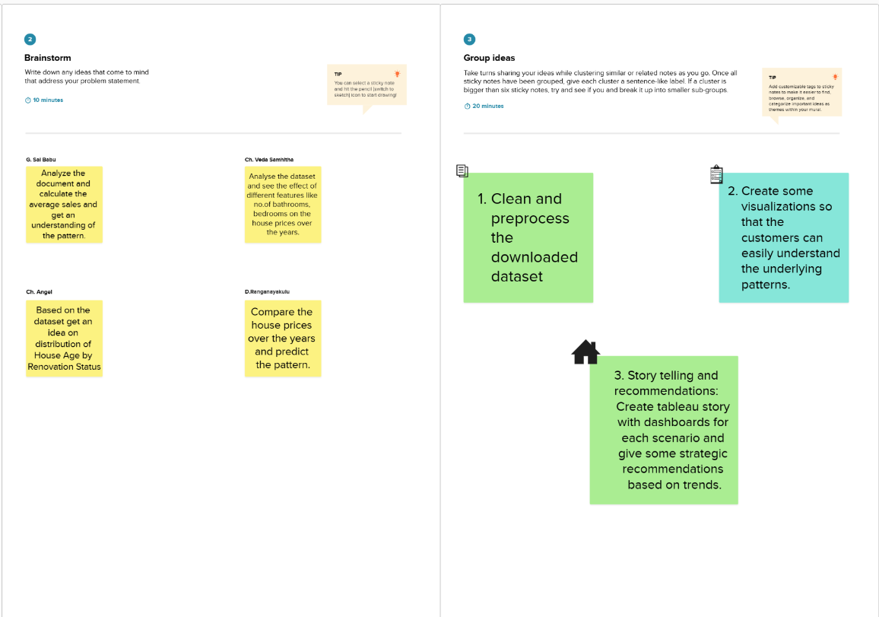

**Step-3: Idea Prioritization**

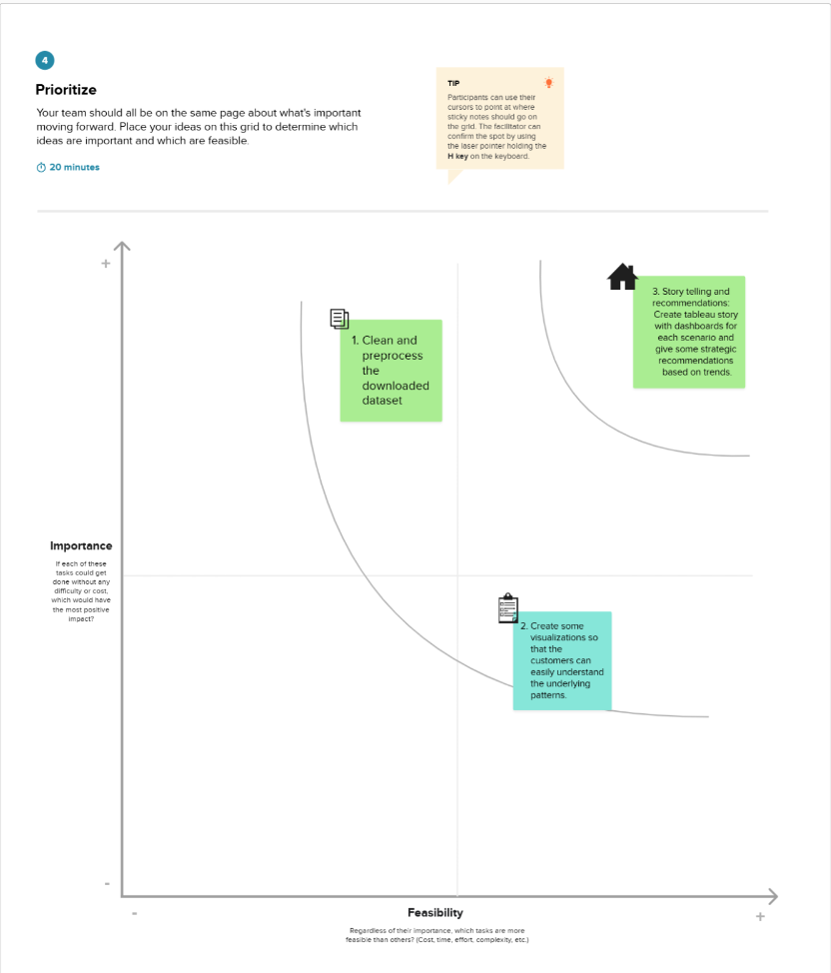

## 3. REQUIREMENT ANALYSIS

### 3.1 Customer Journey Map

The **Customer Journey Map** visualizes how users interact with the Housing Market Trends Dashboard at various stages of usage. It highlights their **experience**, **interactions**, **digital touchpoints**, **goals**, and potential **opportunities for improvement**.

**Stages & Experiences**

* Users begin by logging in to view key data insights like average sale price, total area, and renovation trends.
* They interact with KPI cards (Activities 1.1 to 1.3), then explore additional visuals (Activities 1.4 to 1.6).
* Tableau Public dashboards provide a quick snapshot of housing market performance.

**Interactions**

* Users click through interactive cards and charts.
* They compare visual elements side-by-side for clearer insight.
* Fast navigation across the dashboard helps in better performance evaluation.

**Digital Touchpoints**

* KPIs, bar charts, and pie charts are used for visual comparisons.
* Dashboards offer quick summaries and report-ready visualizations.
* Features like filters, download options, and tooltips enhance usability.

**Goals & Motivations**

* Users want to understand pricing trends and renovation effects without having to scroll through spreadsheets.
* They aim to share insights quickly with stakeholders and make data-driven decisions.
* Easy-to-use dashboards support guided storytelling and real-time exploration.

**Opportunities to Improve**

* Add version history and update notifications for better change tracking.
* Improve filter performance and allow seamless switching between views.
* Enable snapshot downloads and reloading without losing filters.

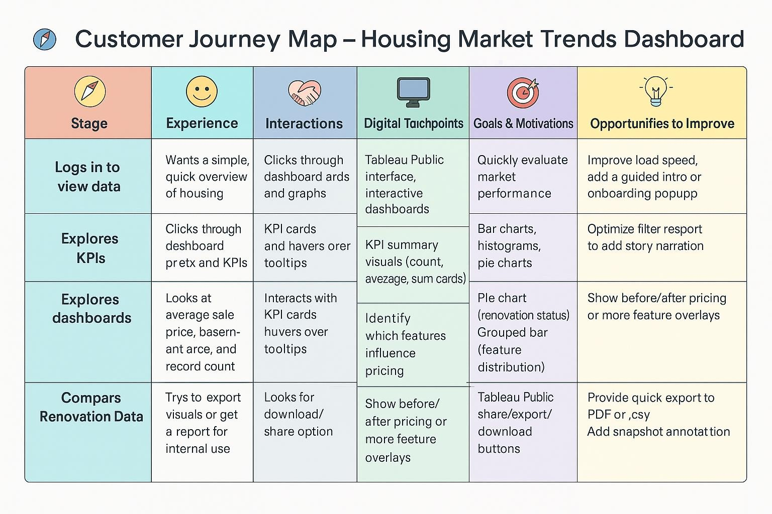

### 3.2 Solution Requirement

**Functional Requirements:**

Following are the functional requirements of the proposed solution.

|  |  |  |
| --- | --- | --- |
| **FR No.** | **Functional Requirement (Epic)** | **Sub Requirement (Story / Sub-Task)** |
| FR-1 | Data Collection | Upload housing dataset in CSV format |
| FR-2 | Data Preparation | Clean, filter, and transform data using Tableau Prep |
| FR-3 | KPI Visualization | Display average sale price, total records, and basement area KPIs |
| FR-4 | Feature-based Visualization | Visualize house age by renovations, bathrooms, bedrooms, and floors |
| FR-5 | Dashboard Sharing | Export or share dashboard via Tableau Public link |

**Non-functional Requirements:**

Following are the non-functional requirements of the proposed solution.

|  |  |  |
| --- | --- | --- |
| **FR No.** | **Non-Functional Requirement** | **Description** |
| NFR-1 | Usability | Dashboard should be easy to navigate and understand for all user roles |
| NFR-2 | Security | Only authorized users should upload or modify data |
| NFR-3 | Reliability | Dashboard should load consistently without failures |
| NFR-4 | Performance | Load and refresh time should be under 5 seconds for average datasets |
| NFR-5 | Availability | Dashboard must be available at all working hours without major downtime |
| NFR-6 | Scalability | Solution must support growing datasets and allow adding new visual modules |

### 3.3 Data Flow Diagram

**Data Flow Diagrams:**

A Data Flow Diagram (DFD) is a traditional visual representation of the information flows within a system. A neat and clear DFD can depict the right amount of the system requirement graphically. It shows how data enters and leaves the system, what changes the information, and where data is stored.

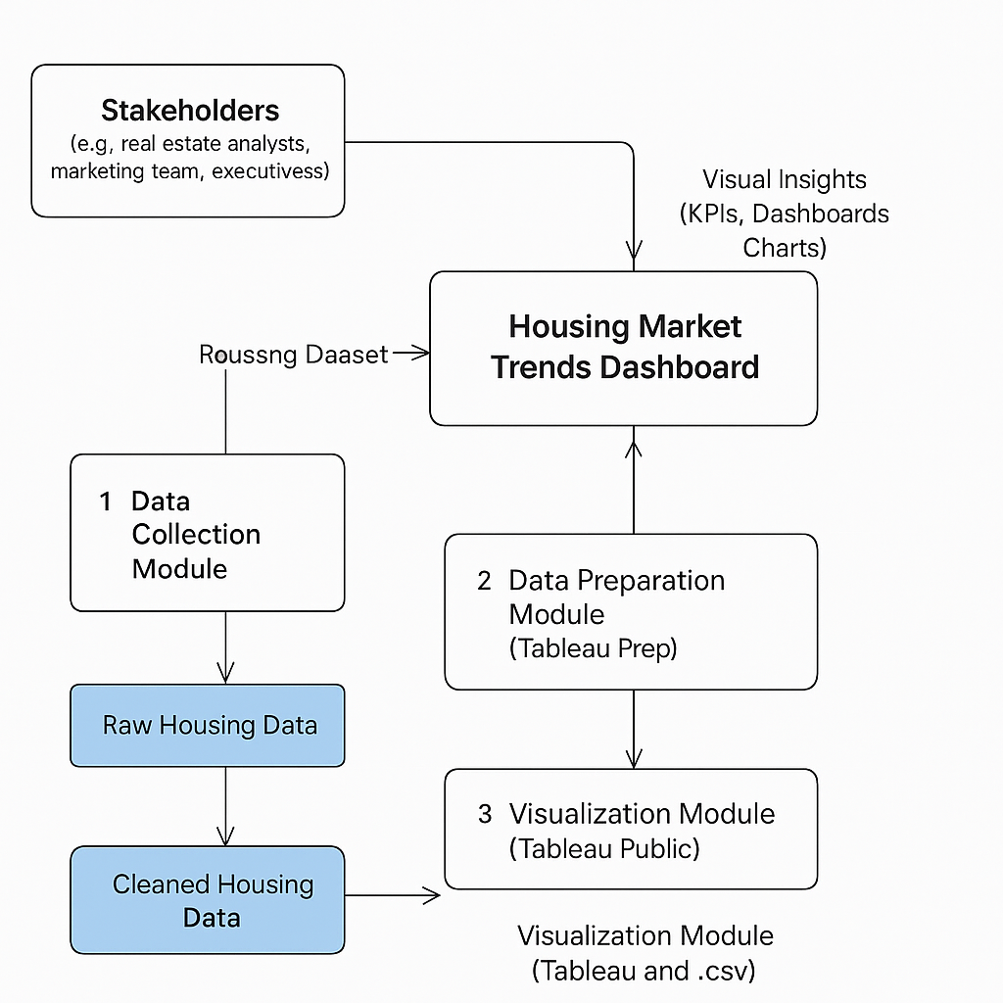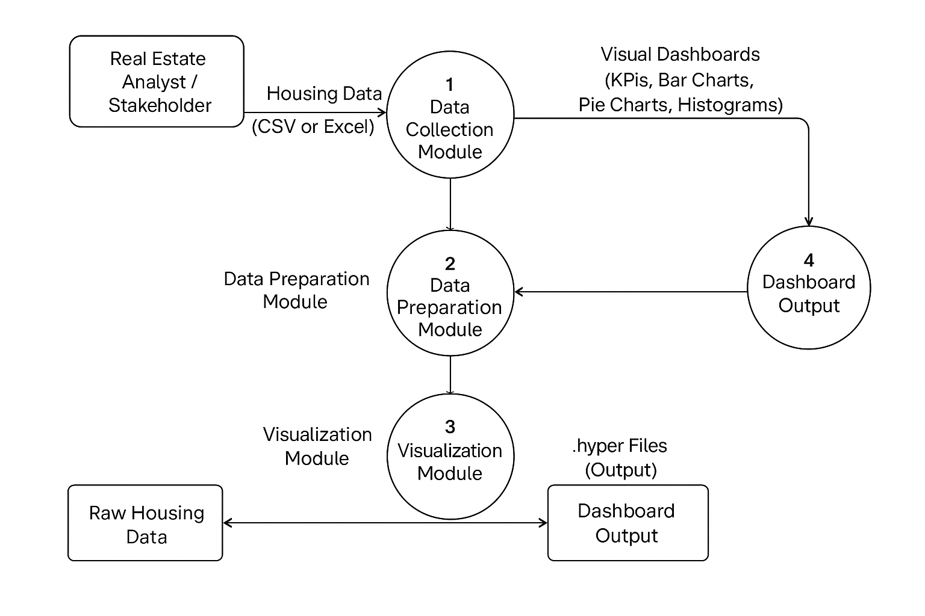

## User Stories

Use the below table to define user stories for this project:

|  |  |  |  |  |  |  |
| --- | --- | --- | --- | --- | --- | --- |
| User Type | Functional Requirement (Epic) | User Story Number | User Story / Task | Acceptance Criteria | Priority | Release |
| Analyst | Data Collection | USN-1 | As an analyst, I want to upload the raw housing dataset to begin the data preparation process. | Dataset is uploaded successfully | High | Sprint-1 |
| Analyst | Data Cleaning & Transformation | USN-2 | As an analyst, I want to clean and filter the dataset using Tableau Prep for analysis. | Cleaned dataset is ready for export | High | Sprint-1 |
| Stakeholder | Visualization – KPIs | USN-3 | As a stakeholder, I want to see overall KPIs like average price and record count in the dashboard. | KPIs display correct values | High | Sprint-2 |
| Stakeholder | Visualization – Renovation | USN-4 | As a stakeholder, I want to compare renovation impact on sale prices using visualizations. | Histogram correctly shows renovation years vs sale prices | Medium | Sprint-2 |
| Stakeholder | Visualization – Age Features | USN-5 | As a stakeholder, I want to analyze house age against bathrooms, bedrooms, and floors. | Grouped bar chart displays counts accurately | High | Sprint-3 |
| Manager | Dashboard Sharing | USN-6 | As a manager, I want to download or share the dashboard insights with my team. | Dashboard is shareable via Tableau link or export | Medium | Sprint-4 |

### 3.4 Technology Stack

Tableau Public, Tableau Prep, Microsoft Excel, CSV dataset

**Table-1 : Components & Technologies:**

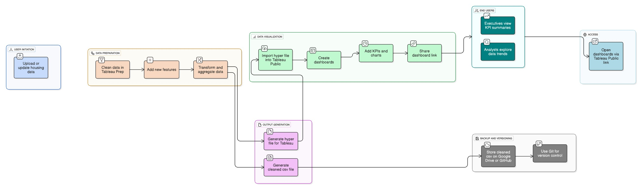

|  |  |  |  |
| --- | --- | --- | --- |
| **S.No** | **Component** | **Description** | **Technology** |
| 1 | User Interface | Final dashboard seen by end users | Tableau Public, HTML, Flask |
| 2 | Data Source | Housing dataset source | Google Drive / Local CSV |
| 3 | Data Collection | Gathering dataset for analysis | Manual / Scripted download |
| 4 | Data Preparation | Cleaning & transformation | Tableau Prep |
| 5 | Data Visualization | Building charts & visuals | Tableau Public Desktop |
| 6 | Dashboard & Story | Visual storytelling with filters | Tableau Story |
| 7 | Web Integration | Embedding dashboards into UI | Flask (Python Web Framework) |
| 8 | Hosting Infrastructure | Hosting the Flask app | Localhost / Web server |

**Table-2: Application Characteristics:**

|  |  |  |
| --- | --- | --- |
| **S.No** | **Characteristics** | **Description & Technology** |
| 1 | Open-Source Frameworks | Tableau Public, Flask |
| 2 | Security Implementations | Dataset access via local storage or private Tableau links |
| 3 | Scalable Architecture | Layered and modular architecture flow |
| 4 | Availability | Accessible via Tableau Cloud and Flask Web App |
| 5 | Performance | Optimized Tableau dashboards using filters and cache |

## 4. PROJECT DESIGN

### 4.1 Problem–Solution Fit

**Problem–Solution Fit**

**The Problem:**

Real estate analysts and decision-makers at ABC Company are overwhelmed by large, unstructured housing datasets. They struggle to identify how renovations and house features like bathrooms, bedrooms, and floors influence sale prices. Manual analysis through spreadsheets is slow, inefficient, and leads to delayed or unclear insights.

**The Solution:**

A Tableau-based interactive dashboard that visually presents key metrics such as average sale prices, renovation impact, and feature-wise house age distribution. Built using Tableau Prep for clean and accurate data, the dashboard simplifies complex data into easy-to-understand visuals and supports fast, data-driven decision-making.

**Why It Fits:**

The solution solves the exact pain point: turning raw data into actionable insights. It matches users' workflows, saves time, improves accuracy, and empowers ABC Company to make confident real estate investment decisions.

**Purpose:**

* To simplify complex housing data and make it accessible to non-technical users.
* To reduce time spent on manual analysis and increase efficiency.
* To help users quickly spot patterns and make strategic, data-driven decisions.
* To replace static reports with dynamic, shareable visualizations.
* To ensure ABC Company can track, interpret, and respond to housing market trends in real time.

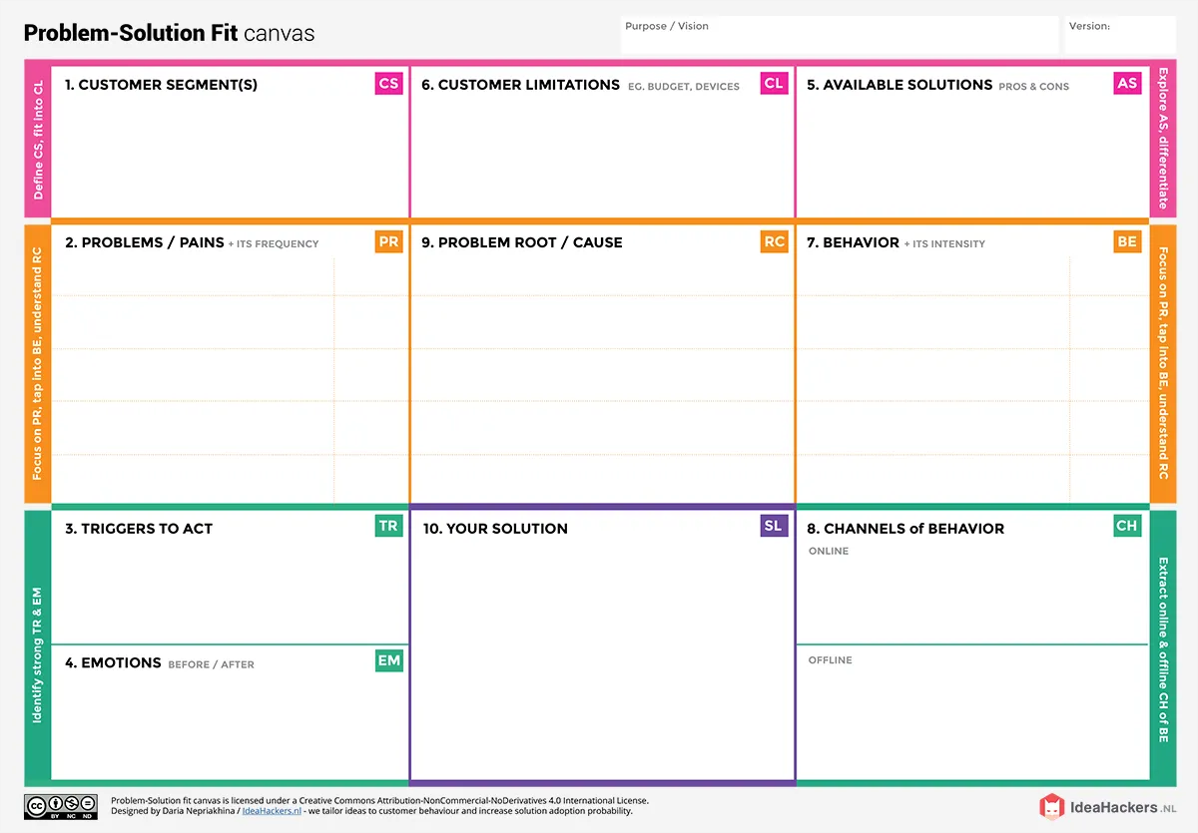

The core issue lies in the unstructured and complex

nature of housing data, which makes it difficult for users

to extract meaningful insights. Analysts and decision

-

makers rely on spreadsheets and

static reports that do not

highlight trends effectively. Existing tools often lack

interactivity and clarity, slowing down the analysis

process. Additionally, many users are not fully equipped

with advanced data visualization skills. This leads to

ineffic

iencies in pricing decisions, renovation planning,

and overall market strategy. As a result, the organization

struggles to make timely, data

-

driven decisions.

Real estate analysts, marketing teams, and

executives at ABC Company who use housing data

to inform pricing strategies, renovation plans, and

market

forecasting.

These users struggle with extracting insights from

raw housing data. They lack clear, visual tools to

understand how features like

renovations, house

age, and layout impact sale prices.

1.

Request for renovation impact

analysis

.

.

2

Need to update pricing strategies

3.

Management asks for visual reports

Before: Frustrated, Overwhelmed, Uncertain

After: Confident, Clear, Relieved.

Currently, they rely on Excel sheets, CSV exports,

and static reports tha

t are time

-

consuming and

difficult to interpret. They manually filter and

compare data across multiple dimensions without

visual aid.

Users may lack advanced Tableau skills and rely heavily on BI teams

for insights. They face t

ime constraints and struggle with

unstructured, complex housing data. Resistance to change and limited

access to tools further slow down adoption of visual, interactive

solutions.

Users often

**manually analyze raw spreadsheets**

to find pricing trends and renovation patterns,

which is

**time**

**-**

**consuming and mentally**

**exhausting**

. They

**frequently request simplified**

**visuals or filtered reports**

, showing a

**high**

**dependency**

on others for insights. This behavior

is

**repetitive and urgent**

, espe

cially during

reporting cycles or strategic reviews, indicating

**strong intensity and critical need**

for a better

solution.

We offer an

**interactive Tableau dashboard**

that

transforms raw housing data into

**clear, visual**

**insights**

. It highlights trends in

**sale price,**

**renovation impact, and house features**

using KPIs,

charts, and filters. The dashboard is

**easy to**

**navigate**

, reduces manual effort, and helps users

**make faster,**

**data**

**-**

**driven decisions**

. It fits

seamlessly into existing workflows and supports

both analysts and executives in understanding

market dynamics effectively.

Business Intelligence tools like Tableau or Power BI

Internal company portals or data dashboards

Virtual meetings (Zoom, Microsoft Teams) for data discussions

Printed reports used in strategy or review meetings

Whiteboard sessions for discussing trends and metrics

In

-

person team huddles or status briefings

### 4.2 Proposed Solution

|  |  |  |
| --- | --- | --- |
| S.No. | Parameter | Description |
| 1 | Problem Statement (Problem to be solved) | Real estate analysts and stakeholders at ABC Company face difficulty identifying how house features and renovations affect sale prices due to unstructured housing data and lack of visual analysis tools. |
| 2 | Idea / Solution Description | Develop an interactive Tableau dashboard using cleaned housing data (via Tableau Prep) that visually presents KPIs, renovation effects, and feature-wise age distribution, enabling fast and confident decision-making. |
| 3 | Novelty / Uniqueness | The solution uniquely integrates data cleaning and visualization in one flow using Tableau Prep and Tableau Public, replacing manual Excel-based processes with automated, real-time visual insights. |
| 4 | Social Impact / Customer Satisfaction | Improves the efficiency and accuracy of real estate decisions, reduces analysis time, enhances communication between teams, and ensures customers (analysts, managers, and executives) have access to meaningful insights instantly. |
| 5 | Business Model (Revenue Model) | Enables ABC Company to optimize property pricing and marketing strategies, leading to higher ROI and better targeting, while also positioning the dashboard as a reusable internal analytics product. |
| 6 | Scalability of the Solution | The dashboard design is scalable for future datasets or new real estate markets. Additional features, filters, or modules can be easily added as business needs grow. |

### 4.3 Solution Architecture

**Solution Architecture Diagram:**

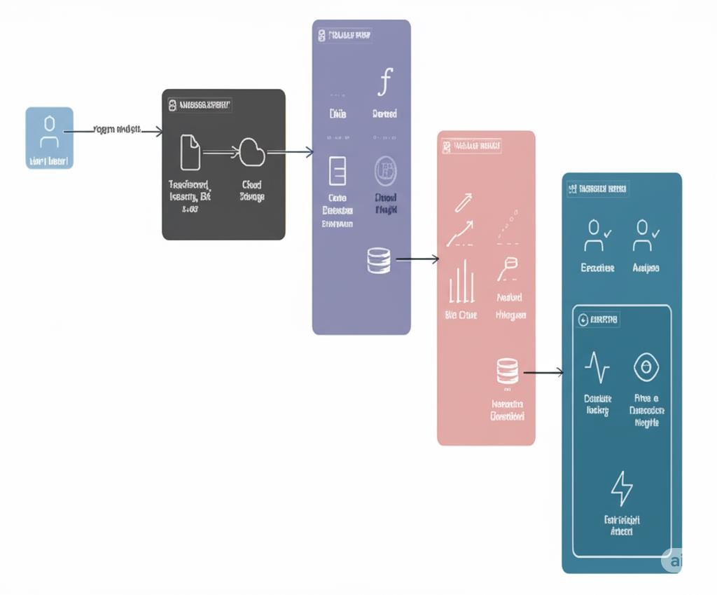

*Architecture and data flow of Visualizing Housing Market Trends: An Analysis of Sale Prices and Features Using Tableau*

## 5. PROJECT PLANNING & SCHEDULING

### 5.1 Project Planning

## Product Backlog, Sprint Schedule, and Estimation :

|  |  |  |  |  |  |  |
| --- | --- | --- | --- | --- | --- | --- |
| Sprint | Functional Requirement (Epic) | User Story Number | User Story / Task | Story Points | Priority | Team Members |
| Sprint-1 | Data Collection | USN-1 | As a data analyst, I want to download the housing dataset for processing. | 2 | High | Gurram Nikhil |
| Sprint-1 | Data Collection | USN-2 | As a data analyst, I want to load the dataset into Tableau Prep. | 1 | High | Arimilli Revanth Narasimha Chowdary |
| Sprint-1 | Data Preparation | USN-3 | As a data analyst, I want to handle missing values in the dataset. | 3 | High | Anakapalli Jyothi Sankara Srinivas |
| Sprint-1 | Data Preparation | USN-4 | As a data analyst, I want to transform categorical features. | 2 | Medium | Anakapalli Jyothi Sankara Srinivas |
| Sprint-2 | KPI Visualization | USN-5 | As a stakeholder, I want to view KPIs like average sale price and record count. | 2 | High | Arepalli Sudeepthi |
| Sprint-2 | Visualization by Renovation | USN-6 | As a stakeholder, I want to see how renovations affect house prices. | 2 | Medium | Arimilli Revanth Narasimha Chowdary |
| Sprint-2 | Feature-based Visualization | USN-7 | As a stakeholder, I want to see house age by bathrooms, bedrooms, and floors. | 3 | High | Gurram Nikhil |
| Sprint-2 | Dashboard Sharing | USN-8 | As a manager, I want to download/share the dashboard with the team. | 1 | Medium | Bhimavarapu Venkata Pavan |

**Project Tracker, Velocity & Burndown Chart**

|  |  |  |  |  |  |  |
| --- | --- | --- | --- | --- | --- | --- |
| Sprint | Total Story Points | Duration | Sprint Start Date | Sprint End Date | Story Points Completed | Sprint Release Date |
| Sprint-1 | 8 | 5 Days | 20 June 2025 | 24 June 2025 | 8 | 24 June 2025 |
| Sprint-2 | 8 | 5 Days | 25 June 2025 | 29 June 2025 | TBD | TBD |

**Velocity :**

**Velocity = Total Story Points Completed / Number of Sprints**

= 8 / 1 = 8 story points/sprint **(after Sprint-1)**

Once Sprint-2 is complete:

Velocity = (8 + 8) / 2 = 8 story points/sprint **(maintained)**

**Burndown Chart:**

Use tools like Excel or Google Sheets to plot:

X-axis: Days of the sprint

Y-axis: Remaining story points

Show planned vs actual burndown

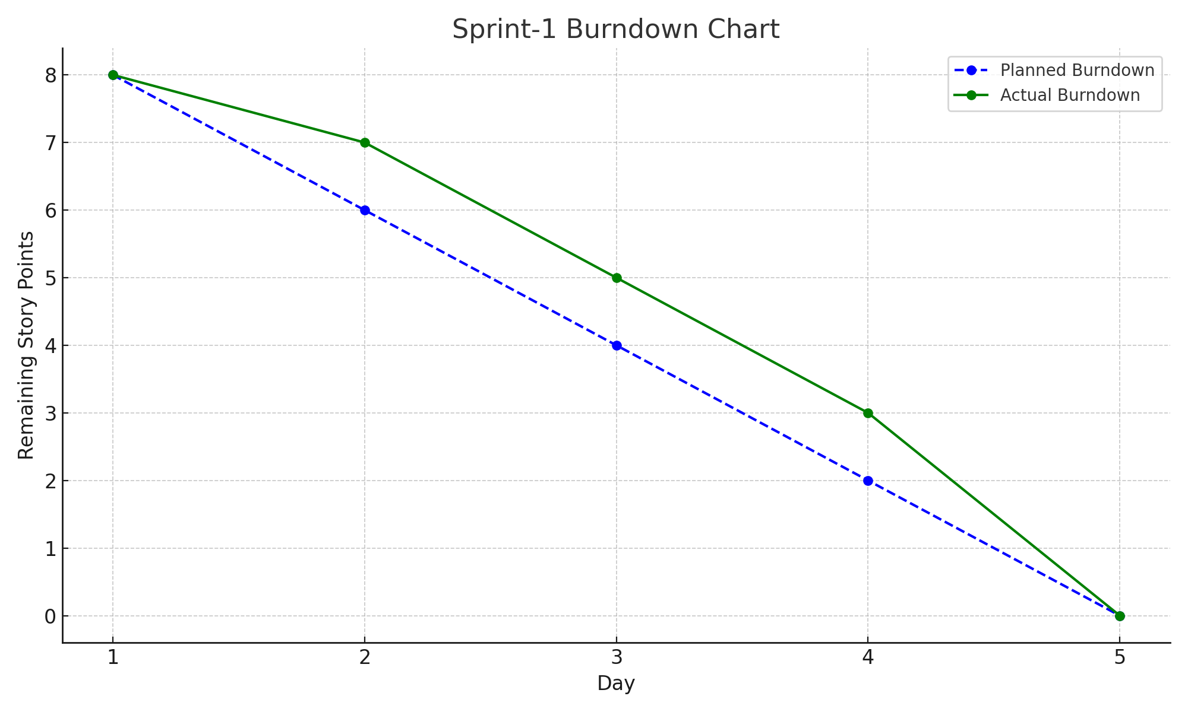

## 6. FUNCTIONAL AND PERFORMANCE TESTING

### 6.1 Performance Testing

## Model Performance Testing:

The project team shall fill the following information in the model performance testing template.

|  |  |  |
| --- | --- | --- |
| S.No. | Parameter | Screenshot / Values |
| 1 | Data Rendered | Housing dataset from CSV, cleaned using Tableau Prep, visualized in Tableau Public |
| 2 | Data Preprocessing | Null values removed, categorical fields standardized, aggregated KPIs calculated |
| 3 | Utilization of Filters | Filters for Renovation Status, Year Built, Bathrooms, Bedrooms, Floors |
| 4 | Calculation Fields Used | Average Sale Price, Years Since Renovation, Age of House, Count of Records |
| 5 | Dashboard Design | KPIs (3), Histogram (1), Pie Chart (1), Grouped Bar Chart (1) → Total: 6 Visualizations |
| 6 | Story Design | Interactive story sequence with titles and dashboard explanations → Total: 6 Views |

## 7. RESULTS

### 7.1 Output Screenshots

Dashboard for Visualizing Housing Markey Trends:

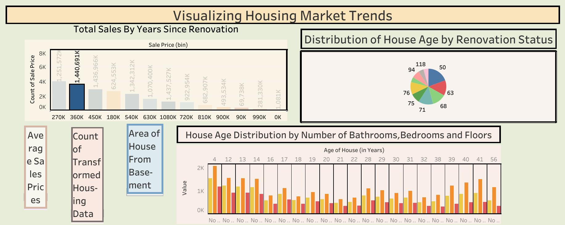

Stories for Visualizing Housing Markey Trends:

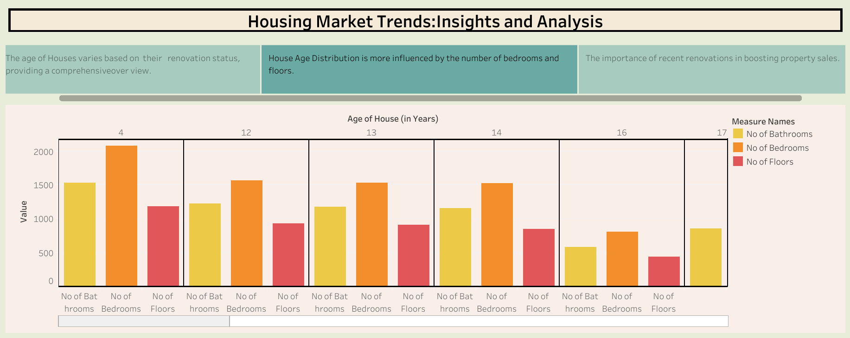

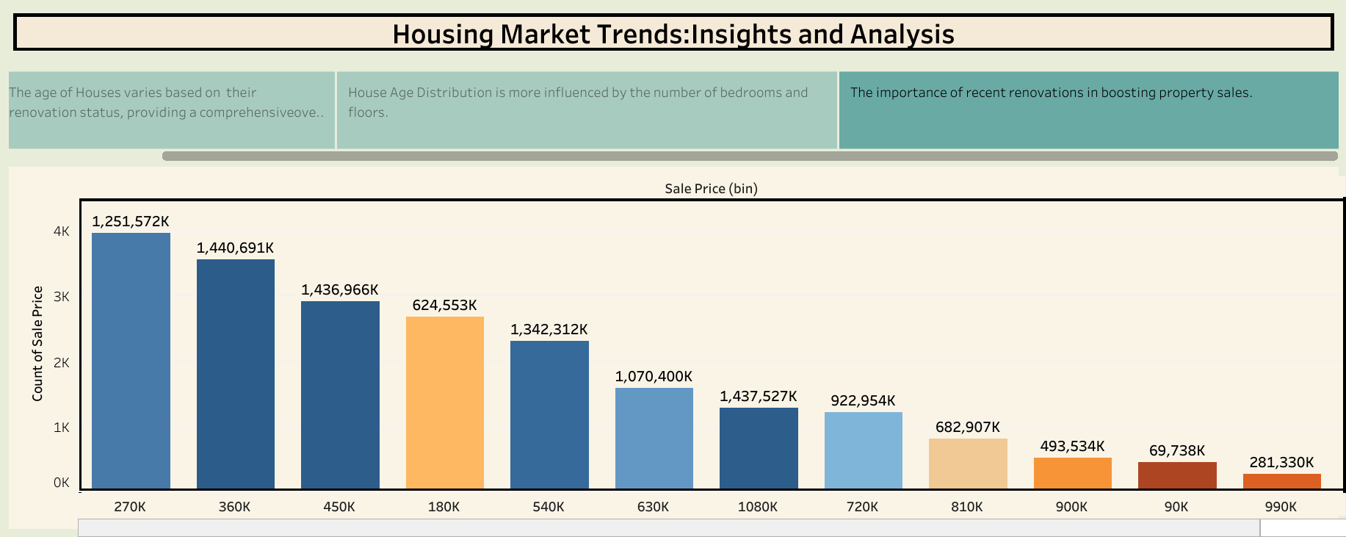

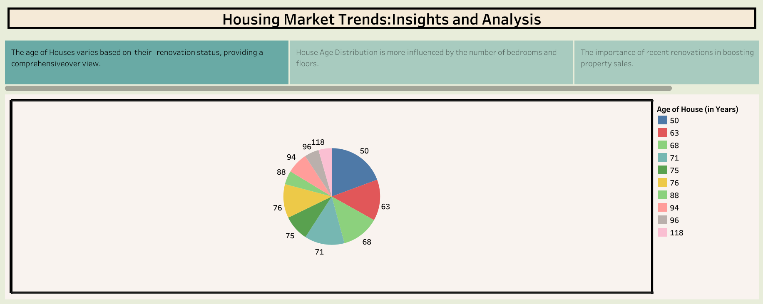

**Links for Dashboard and Stories:**

**for dashboard:**

https://public.tableau.com/views/Dashboard_17509225202630/Dashboard4?:language=en-US&:sid=&:redirect=auth&:display_count=n&:origin=viz_share_link

**for stories:**

https://public.tableau.com/views/story-1_17509334098390/Story3?:language=en-US&:sid=&:redirect=auth&:display_count=n&:origin=viz_share_link

**8. ADVANTAGES & DISADVANTAGES**

**Advantages:**

## Fast insights: Users can quickly understand trends in house prices, renovation effects, and feature-based distributions.

## Visual clarity: Charts and KPIs make complex data easy to interpret.

## Interactive filtering: Users can apply filters and interact with the dashboard to explore specific segments of the data.

## Time-saving: Reduces the need to manually analyze data in Excel or spreadsheets.

## User-friendly: Easy for non-technical stakeholders to gain valuable insights.

## Disadvantages:

## Limited to visualization: The system is designed for analysis and does not support predictive modeling or forecasting.

## Tool dependency: The workflow depends on Tableau Prep and Tableau Public, which may limit integration with other platforms.

## Requires clean data input: Data quality issues can impact the effectiveness of visualizations.

## 9. CONCLUSION

## The project “Visualizing Housing Market Trends: An Analysis of Sale Prices and Features using Tableau” successfully demonstrates how data visualization can simplify complex housing data and provide actionable insights. By utilizing Tableau Prep for data cleaning and Tableau Public for building interactive dashboards, the project enables stakeholders to quickly identify trends in sales prices, renovation impacts, and feature-based distributions such as the number of bathrooms, bedrooms, and floors.

## This solution addresses the challenges of manually analyzing large datasets by offering a visually intuitive and efficient alternative. It supports better decision-making for real estate analysts, marketers, and executives by presenting key performance indicators (KPIs) and comparative visualizations in a user-friendly format.

## Overall, this project enhances the understanding of housing market dynamics and sets a strong foundation for further analytics, such as forecasting or predictive modeling, in the future.

## 10. FUTURE SCOPE

## Incorporate Predictive Analytics: Enhance the dashboard with machine learning models to forecast future house prices based on historical trends and features.

## Expand to Other Geographic Markets: Apply the same visualization framework to datasets from different cities or regions to analyze broader housing trends.

## Integrate Real-Time Data Feeds: Connect the system with live data sources (e.g., MLS databases, API feeds) to keep dashboards continuously updated.

## Enable User Customization: Allow stakeholders to create custom views and filters based on their individual needs or business goals.

## Develop Mobile-Friendly Dashboards: Optimize the dashboards for mobile and tablet interfaces to improve accessibility and convenience.

## 11. APPENDIX

Source Code: <https://github.com/Nikhil-2005-web/housing-market-trends.git>  
GitHub & Project Demo Link: